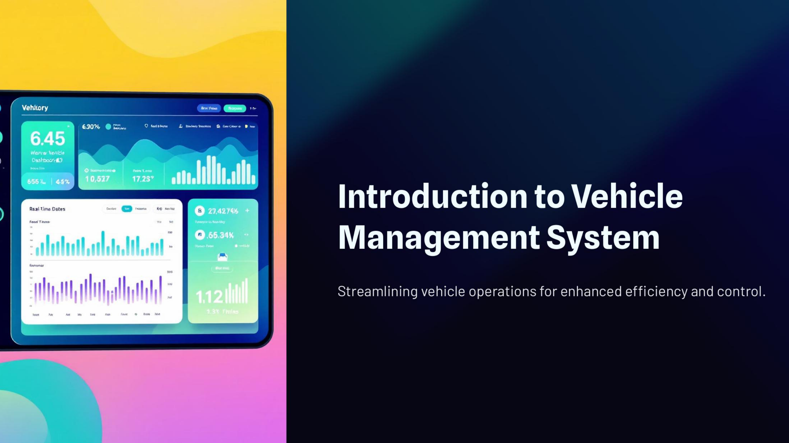



**Team members:**

**1. K. Sri Sai Krishna**

**2. R. Ram Charan**

**3. K. Sri Lasya**

**4. K. Roshini**

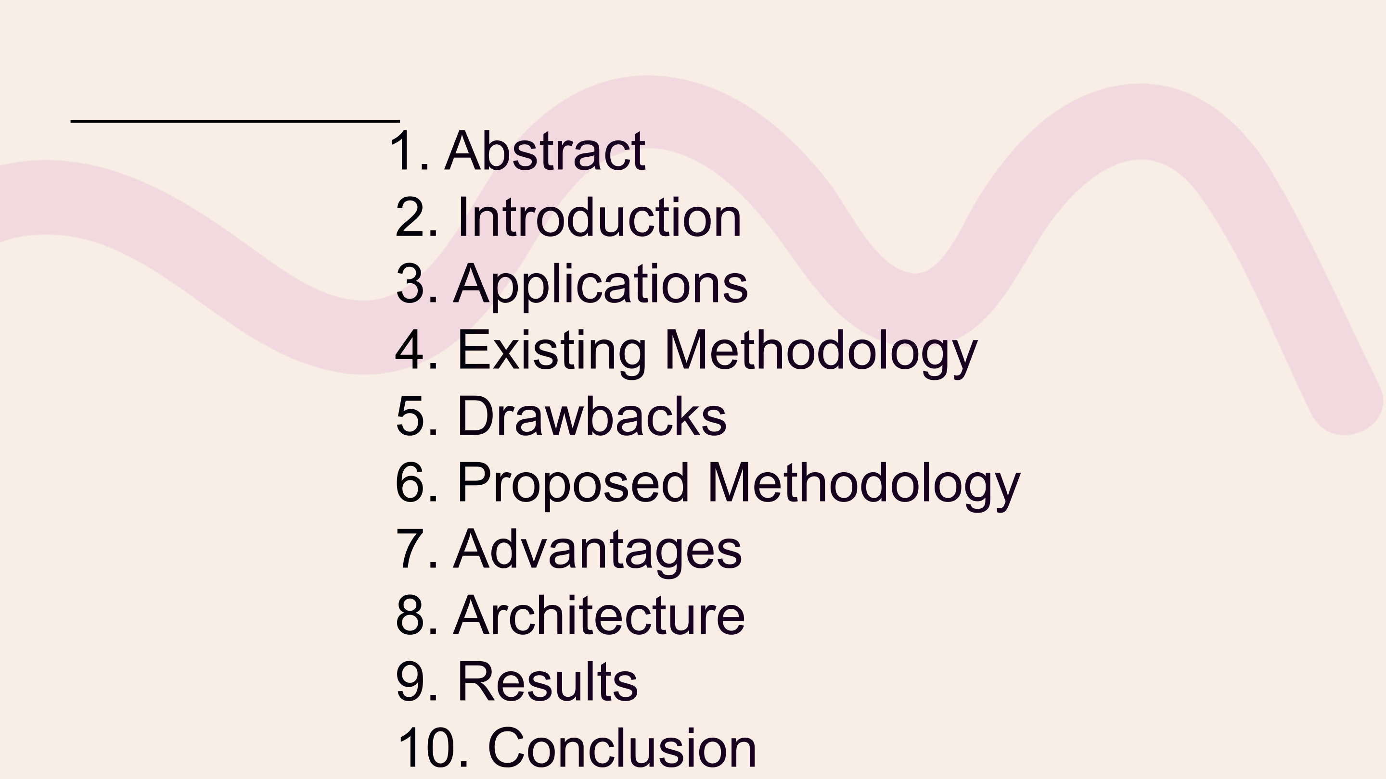

**Index:**

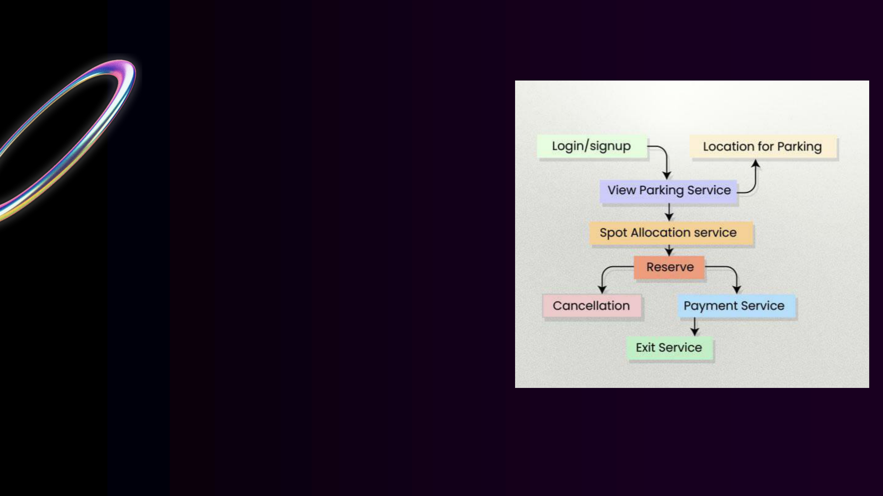

**Abstract:**

The Vehicle Parking   
Management System aims to   
automate parking operations   
such as slot allocation, vehicle   
monitoring, fee calculation, and

record maintenance. It reduces

human effort and improves   
accuracy and security in parking

spaces.

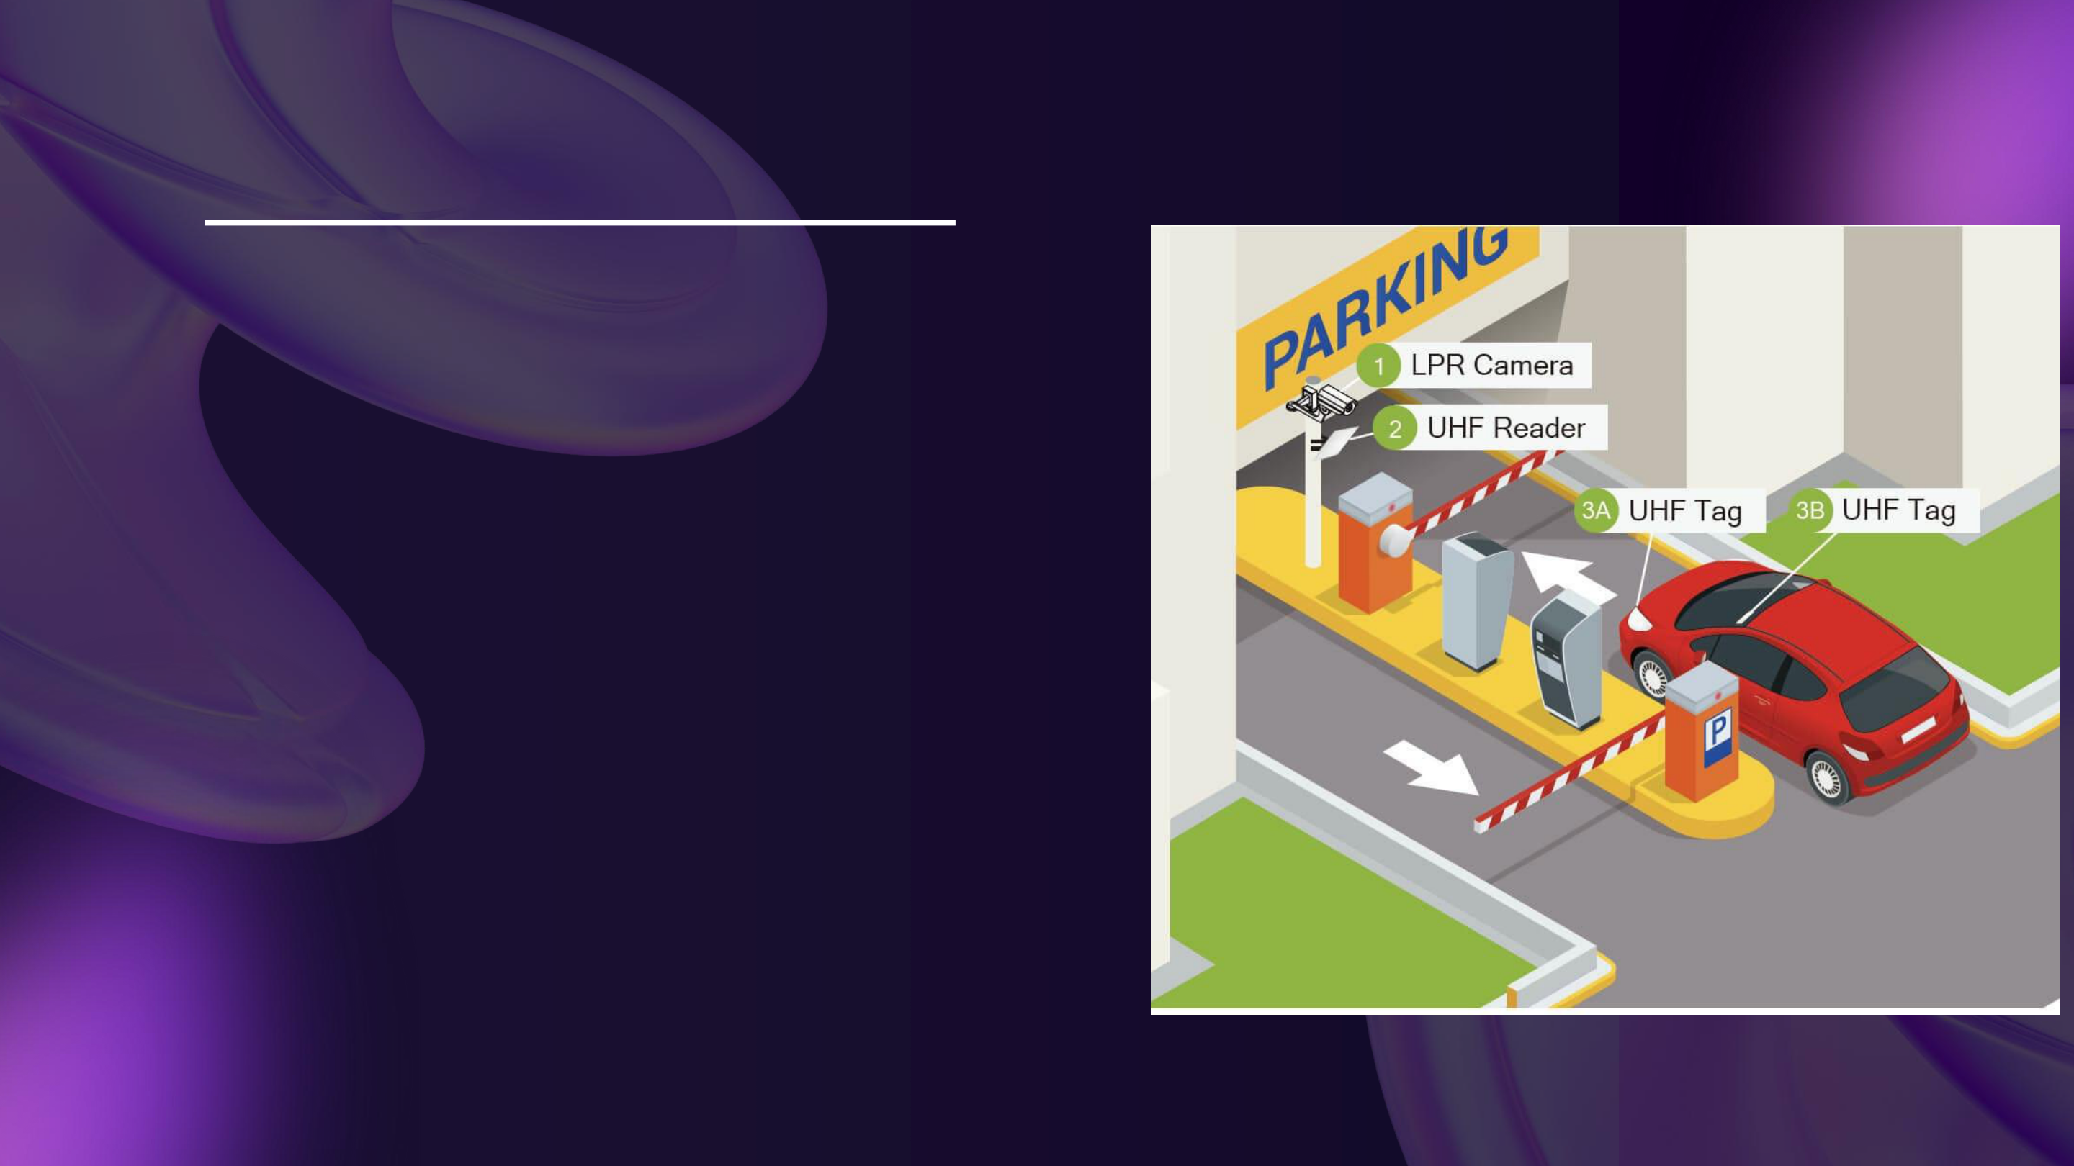

INTRODUCTION:

The project introduces a smart   
system to manage parking slots   
efficiently using automated   
techniques. It ensures proper   
utilization of parking areas and   
reduces congestion and manual

errors.

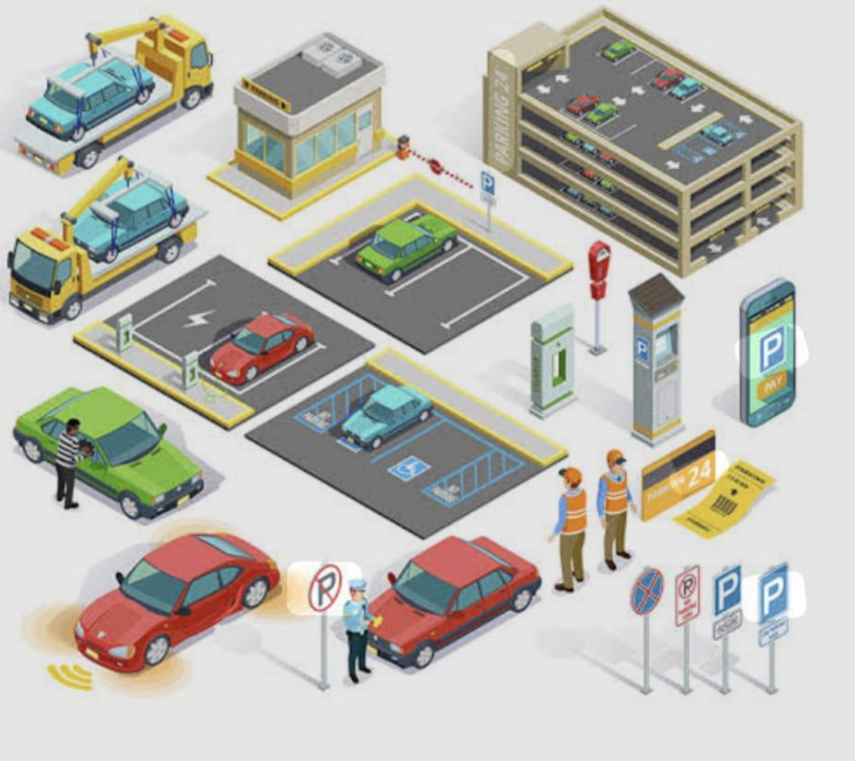

APPLICATIONS:

• Shopping Malls  
• College & Universities   
• Hospitals   
• Commercial buildings   
• Apartments   
• Public parking areas



EXISTING METHODOLOGY:

• Manual entry of

vehicles   
• No automated slot   
 detection

• Paper-based record   
 system   
• High chances of

human error



DRAWBACKS OF EXISTING METHODOLOGY:

• Time-consuming processes • Difficulty in tracking vehicles• Mismanagement of slots   
• Inefficient record keeping



PROPOSED METHODOLOGY:

1.Automated vehicle entry system

2.Real – time slot availability

3.Automated fee calculation

4.Secure database management



ADVANTAGES OF PROPOSED METHODOLOGY:

• Reduces human effort

• Saves time

• Provides real-time updates

**01**

• Increases parking efficiency

• Ensures security and

accuracy



ARCHITECTURE OF PROPOSED METHODOLOGY:

• Input Module

• Slot Allocation Module

• Database

• Billing Module

• Output Display System



CONCLUSION:

A vehicle parking management system project

concludes by providing an efficient , organized

and automated solution for managing parking ,

which enhances user experience , optimizes

space utilization and increases security.

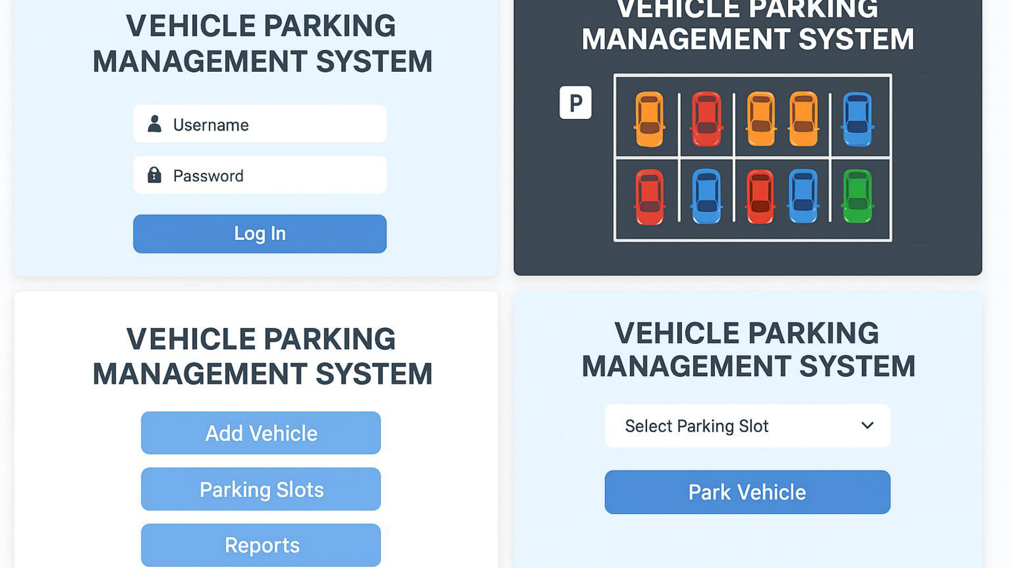

|  |  |
| --- | --- |
|  |  |
|  | ====== VEHICLE PARKING MANAGEMENT SYSTEM  ======  1.Add Vehicle Entry  2. Search Vehicle Details  3. Display All Vehicles  4. Exit  Enter your choice :4  It come backs to the actual code |

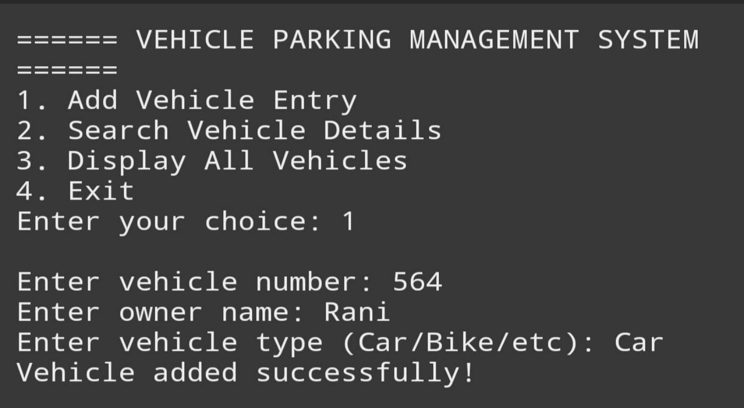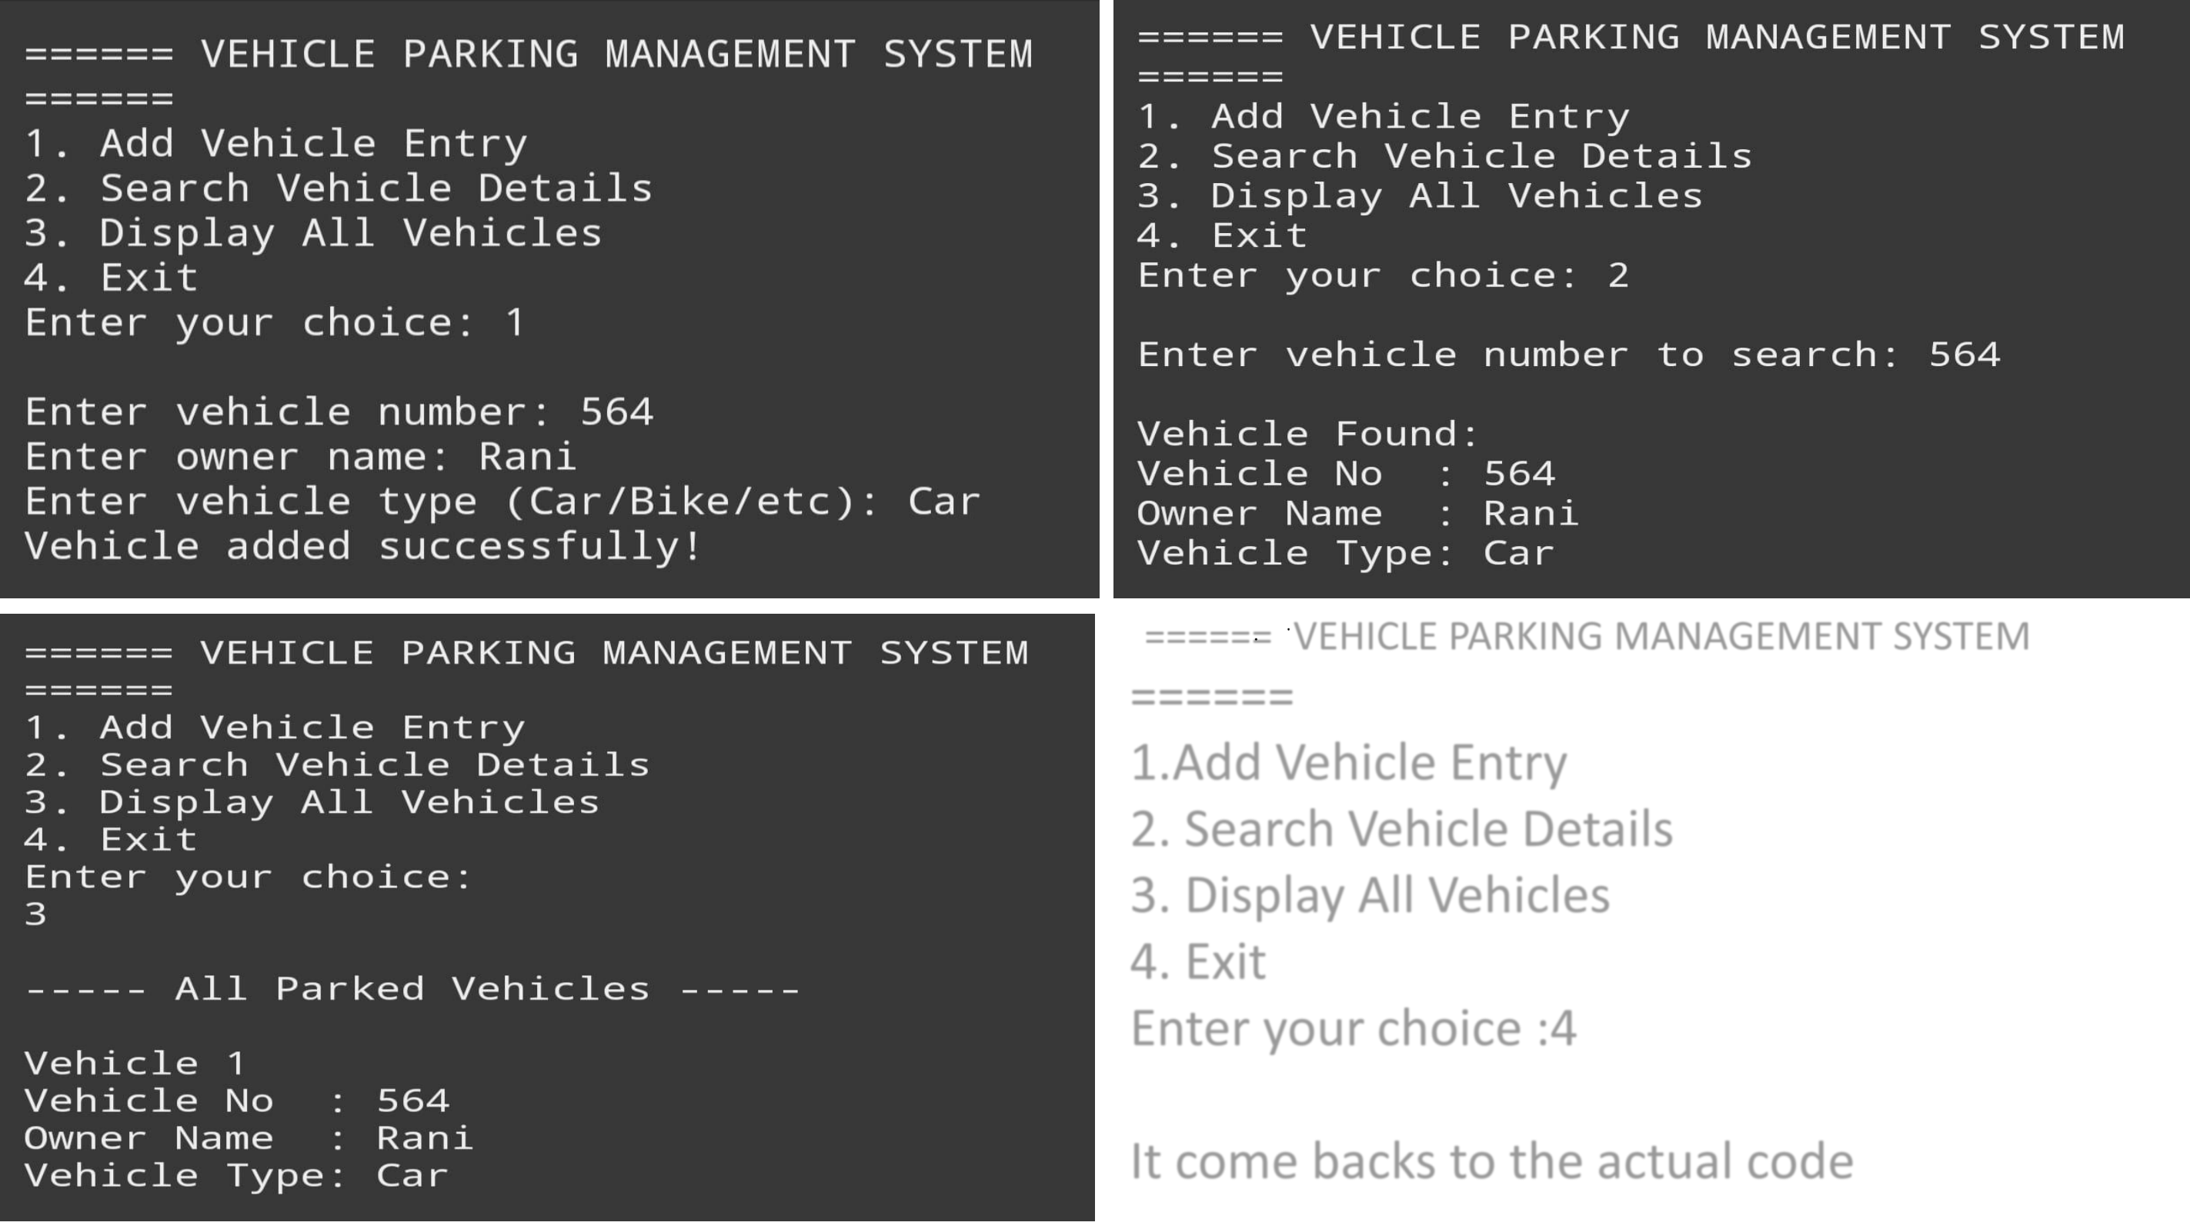



THANK

YOU   
If you have any queries   
 and doubts regarding   
 our project feel free to

ask.